**React-JS:**

1. ReactJs: ReactJS, commonly referred to as React, is an open-source JavaScript library for building user interfaces, particularly for building single-page applications and interactive UI components.
2. Reactjs features:

🡪React makes up everything in components. Each component has its own function which could be handled by different people to work simultaneously.

🡪Reusable components

🡪dynamic web creation

🡪single page application

🡪unidirectional data flow

🡪JSX is used here

🡪Virtual DOM

🡪NPM:

🡪NodeJs: To run javascript outside the browser.

🡪In java, we use JVM, in javascript we have javascript_engine. In java we have JRE, in javascript we have NodeJs.

🡪Nodejs is not installed on client computer, in client side they use browser to run the javascript code. Nodejs is installed in server side for providing environment to run javascript code.

🡪 In JavaScript, there isn't a direct equivalent to a JVM. Instead, JavaScript code is executed in JavaScript engines, which are part of web browsers when running on the client side.

1. Installing nodejs: after installing nodejs in our computer we can easily check whether the things are correctly installed or not and for that we can open the cmd and we can write node –v and for checking the npm we can write npm –v.

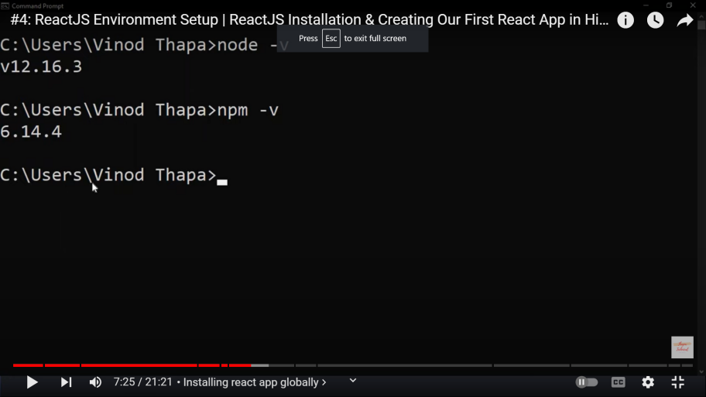

1. Then we will install vs code.
2. After installing both of this we:

A). Installing the app globally means that you can run the application from any directory on your system without specifying the application's path explicitly.

For this we write command in cmd as:

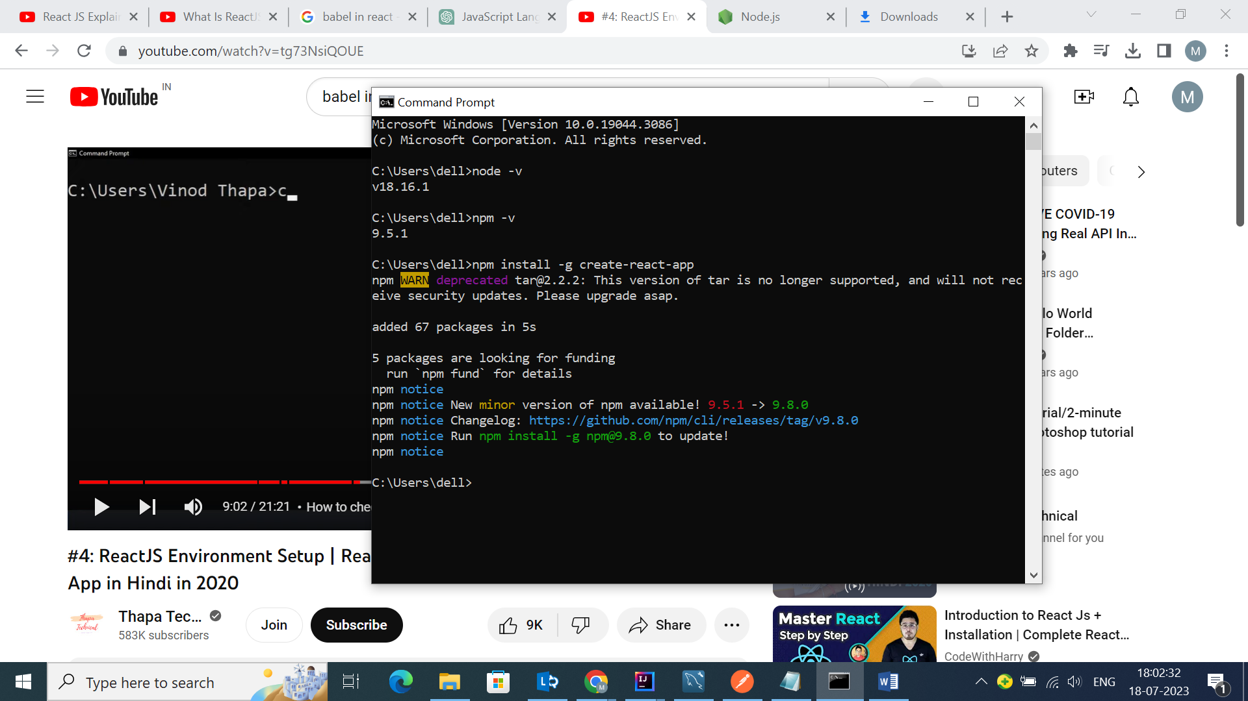

B). If the app is successfully globally installed we check it by writing command:

create-react-app –version

If the version comes everything is running correctly.

C). we change the directory using cd and then we come to folder where we want to create our project and then write a syntax: (note: for going back in directory we use cd\)

create-react-app firstproject

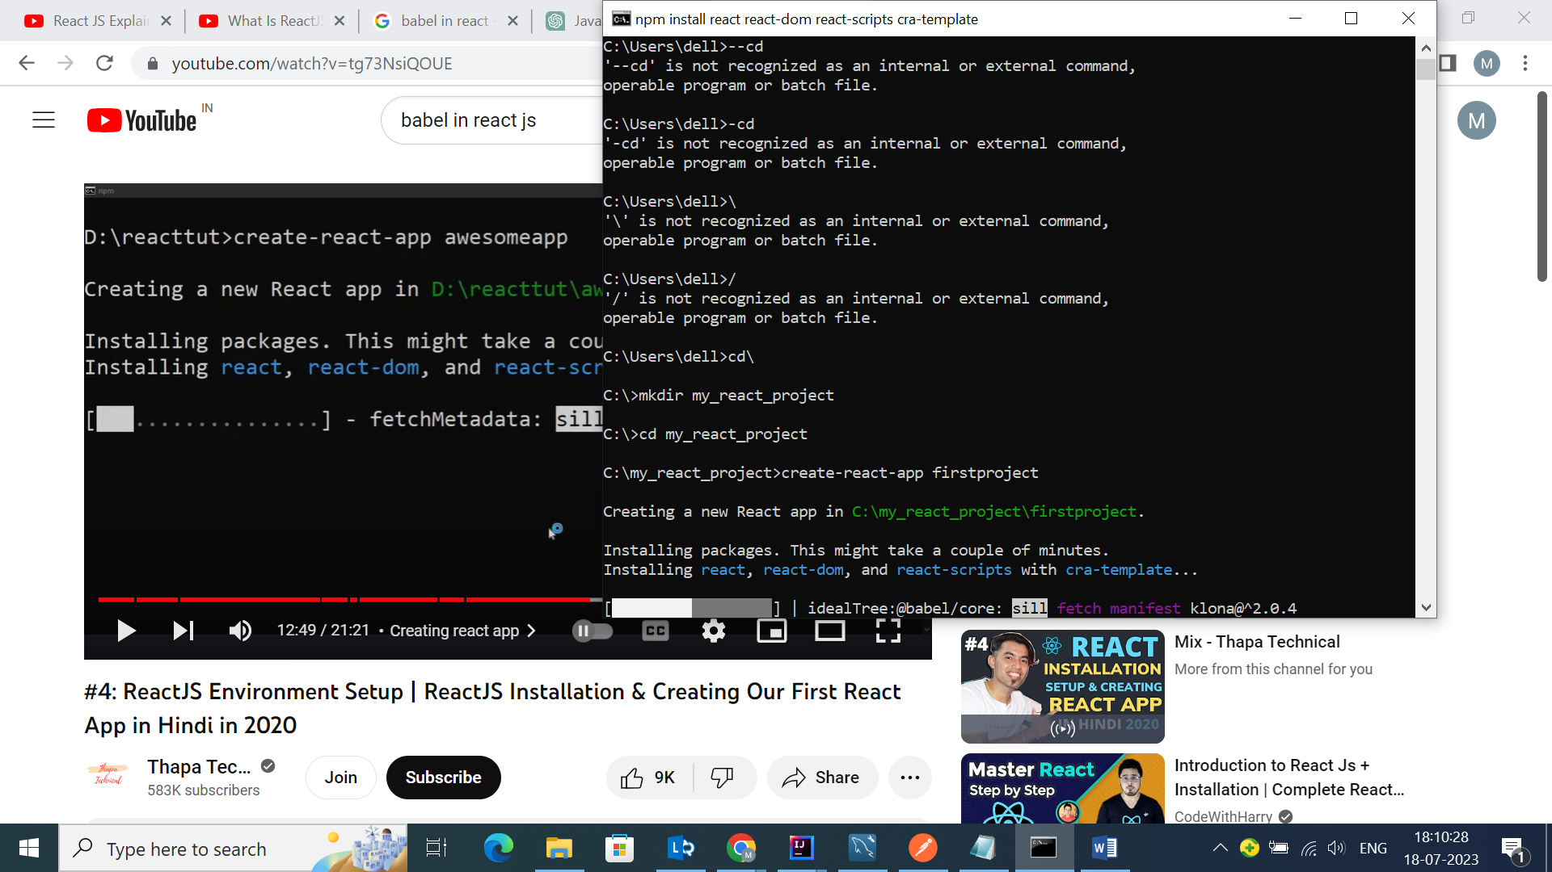

1. Now have to get a server for react so we will write the following syntax in the command prompt.

npm start

1. This command is used to start the development server, which allows you to see your React application in action during development.
2. The **npm start** command will typically trigger a script defined in your project's **package.json** file.
3. Inside Vscode we have to add extensions. They are as follows:

🡪

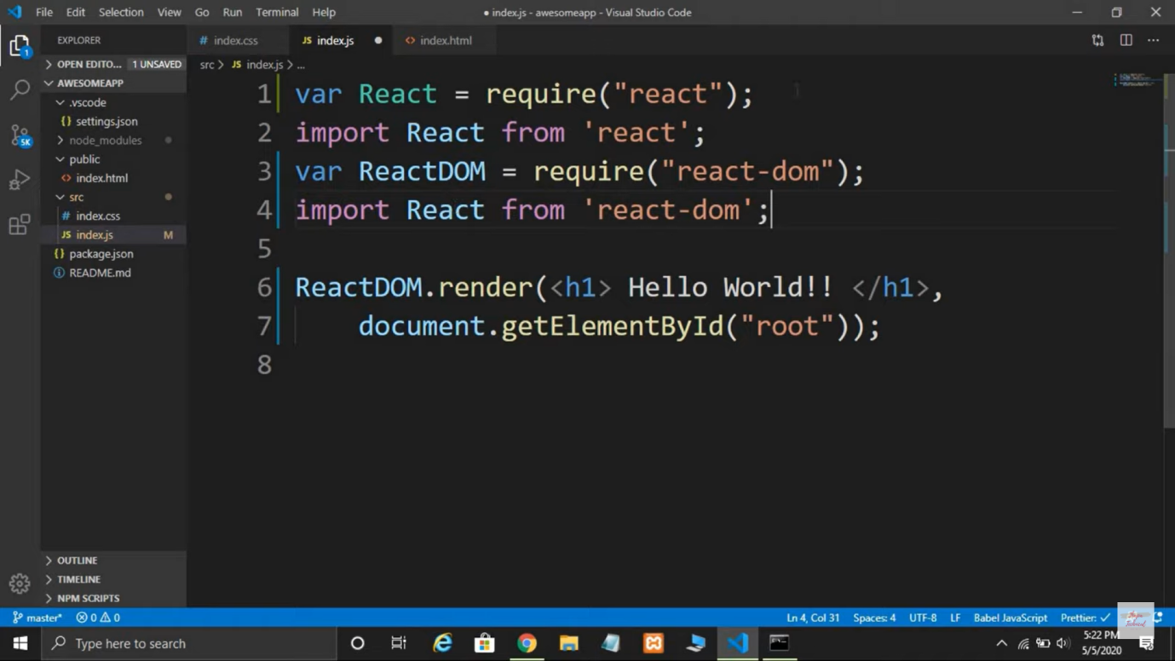

1. For not globally activating the project we write;

🡪npx create-react-app nameofproject

1. Earlier we used to write var react line because it followed old javascript. But with the introduction of modern javascript syntaxes, we need a babel compiler to convert this modern syntax into old syntax which will be understood by the browser so for this reason we import react package. Using var and import is just modernity.

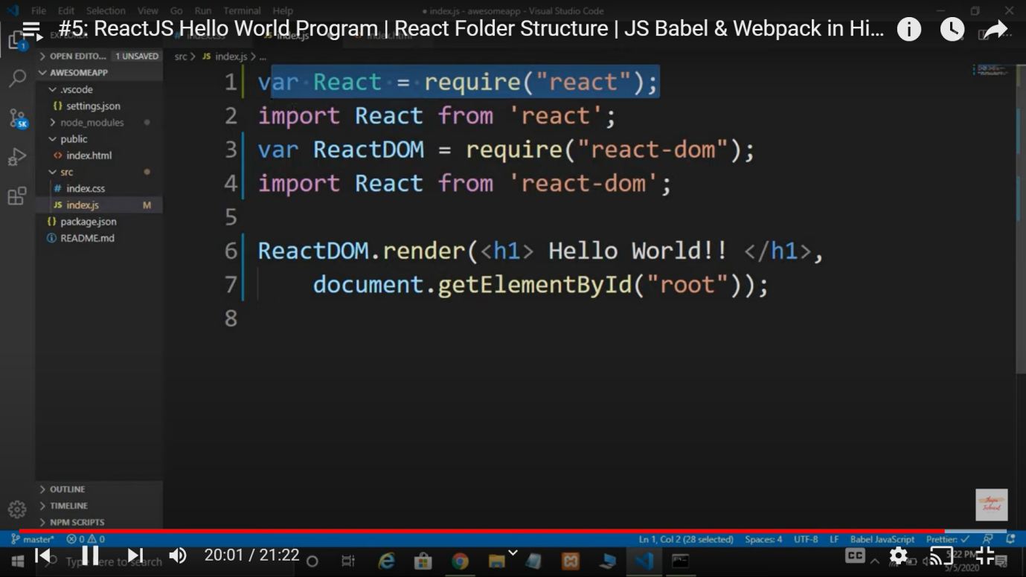

1. ReactDOM is part of ReactDom module. It has several methods which is used in react. ReactDOM.render(kya dikhana hai, kaha dikhana hai);

Example of this is: React DOM.render(<h1>hii..</h1>, document.getElementById(“root”));

1. React module should be in scope when using JSX.

JSX: JSX (JavaScript XML) is a syntax extension for JavaScript that allows you to write HTML-like code within your JavaScript code.

1. Babel convert the modern javascript syntaxes to old understandable syntax i.e., ( JSX into JS ). For example let’s take an example of this:

🡪 React DOM.render(<h1>hii..</h1>, document.getElementById(“root”)); is converted into,

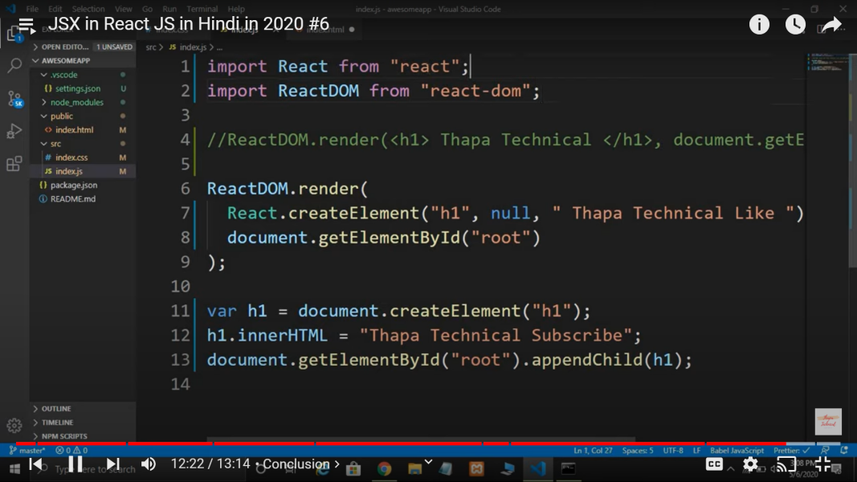

1. We cannot add multiple jsx element to ReactDOM.render attribute, so we put all things under single tag, here we are taking div jsx element.

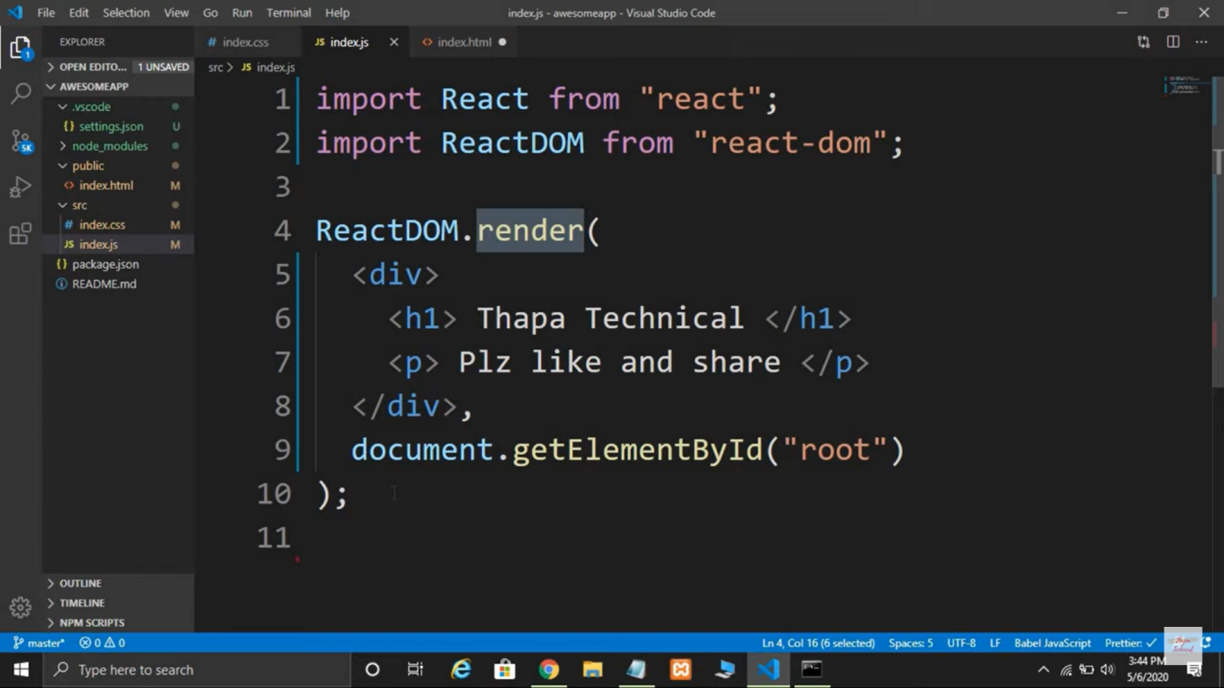

1. We can also use brackets( as an array elemts with commas after each tag) to give multiple jsx element:

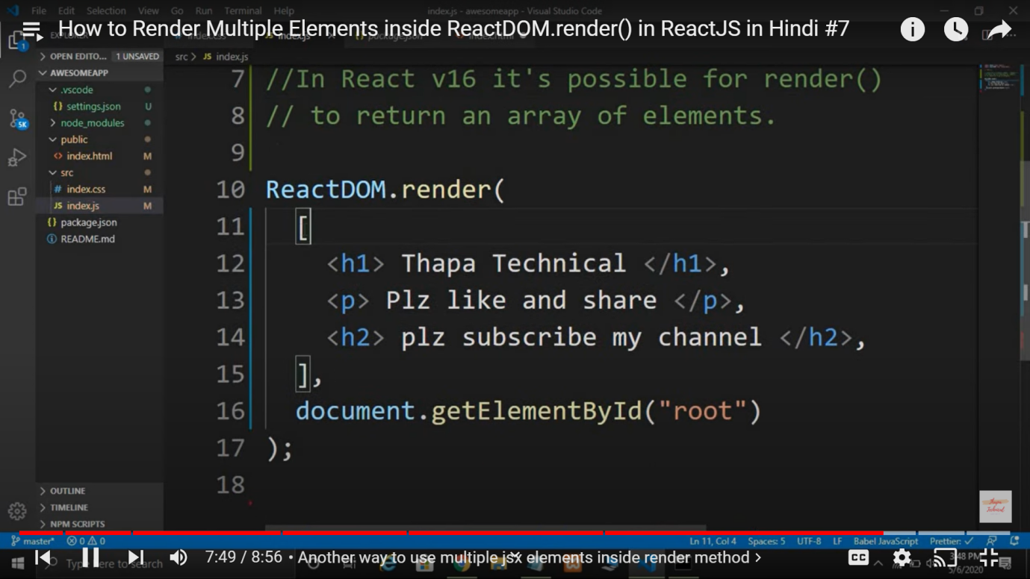

1. We can use another method where we don’t even have to give an extra div to get all the tags in one jsx tag. Instaed of this method we can use React.Fragment tag or just tag brackets <> as follows:

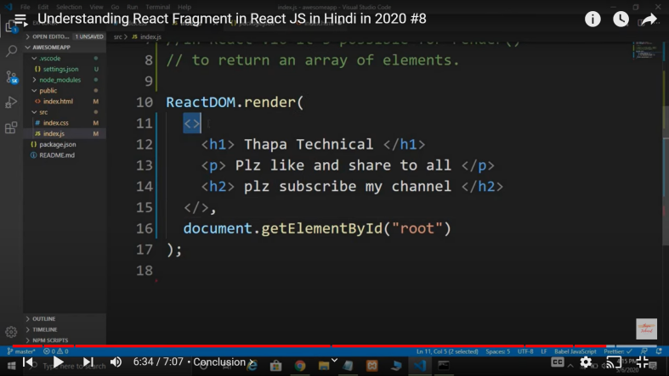

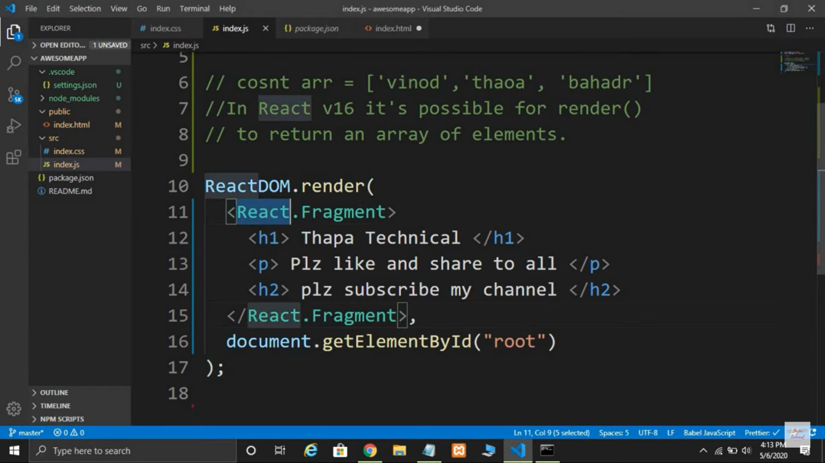

1. If we want to use javascript variables and constants inside jsx elements we have to use curly braces {}. We cannot give statement here, we can only give variables.

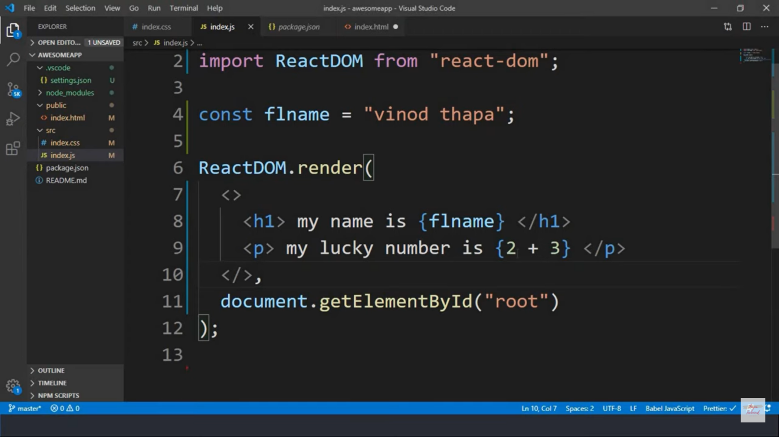

1. If we want to write the text part also inside curly braces when we use back ticks and for variabes then we will use $ dollar sign.

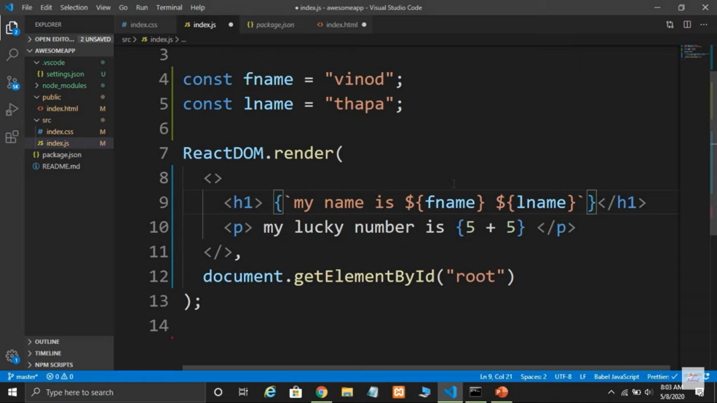

1. We can write attributes of any tag like this, following camel case pattern:

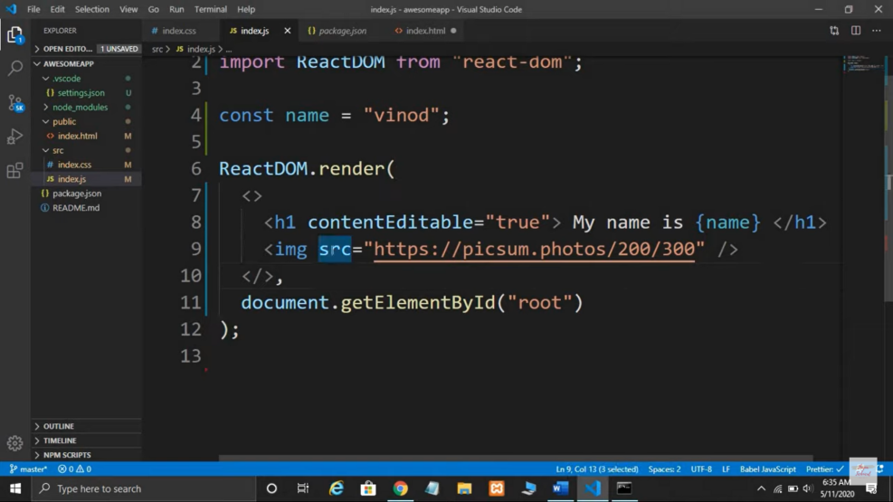

1. In react we cannot use attribute name “class” as it is reserved by react so instead of that we use className in camel case.

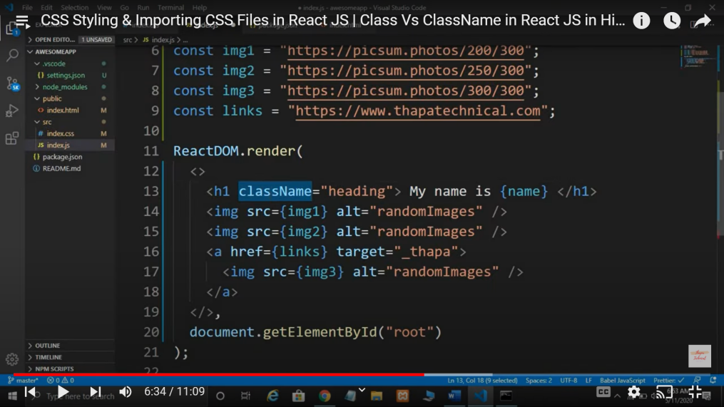

1. To import css class in index.js we use this import way;

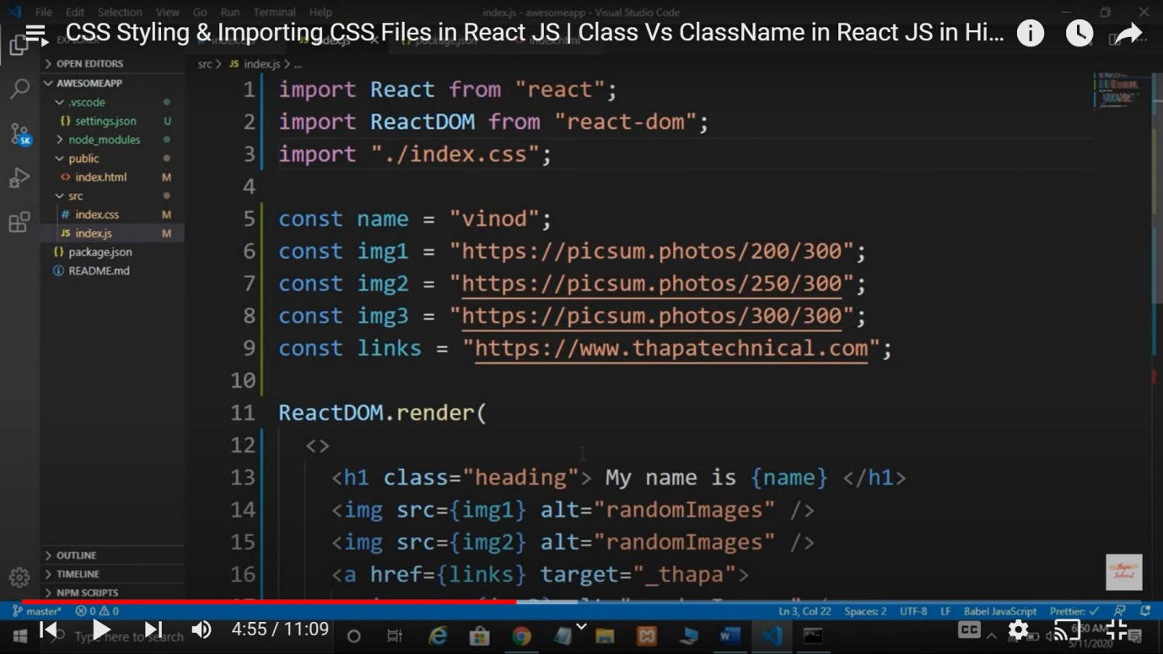

1. Whenever we want to give inline css, we have to give it in object json form. Now to get the inline style we copy and paste the whole object detail we have written above.

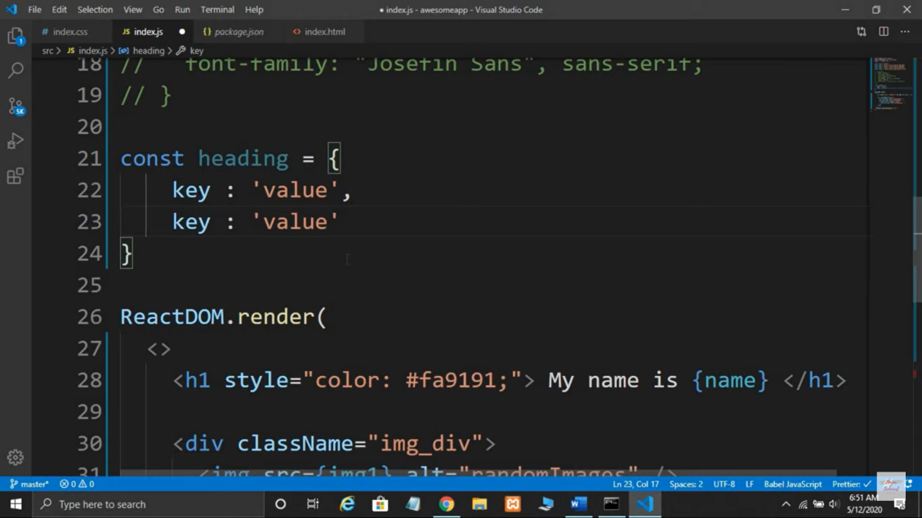

1. <h1 style={ {object info will be here} };

Object info will be here🡪 color:red; backgroundColor:blue;

Here we can see that the attributes are following the camel case. All the kebab case is converted into camel case when we have it in object form.

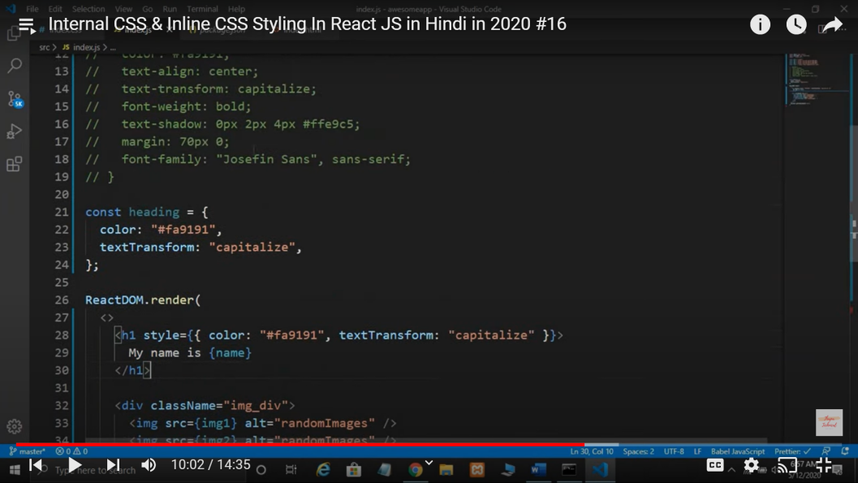

1. We can follow another way to do inline css. We can write the details of css attributes and assign variable to it. We can directly pass that variable to style attribute as follow:

(But we have to make sure that when we are giving key-value pair inside object variable it should be in camel-case)

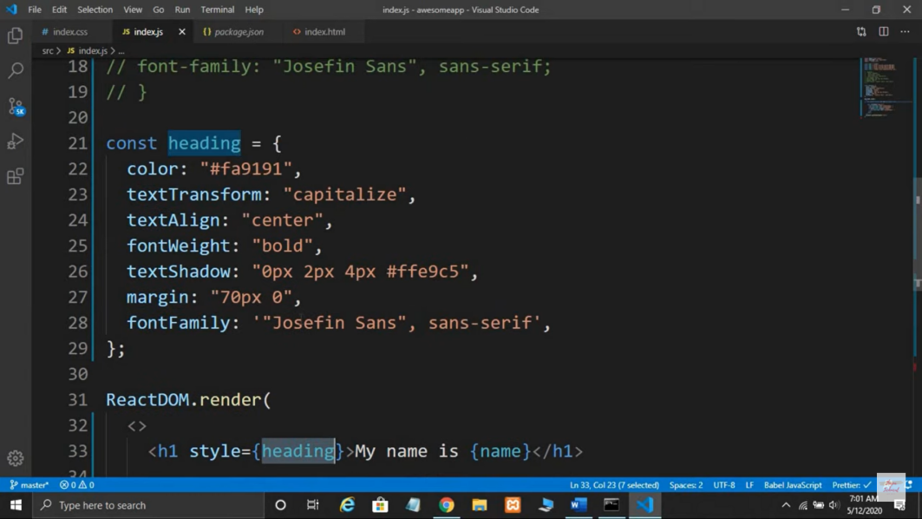

1. Whatever we studied is little old way. The new way is as follows:

The changes we see here is that when we are importing ReactDOM, we have to write ReactDOM from ‘react-dom/client’ and we cannot directly get render method from ReactDOM module. Instead of this first we will make object of this and then try to set the method using that object as follows:

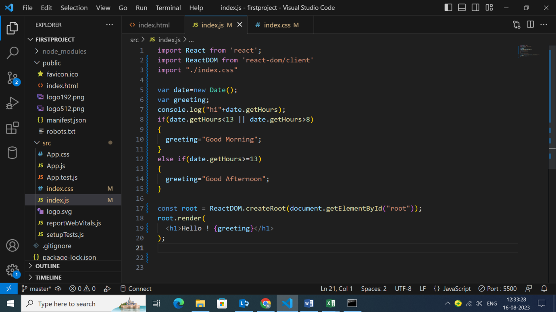

1. To make components we make different .jsx file and write functions inside it. Then call this jsx file in our main page. Here we have made Header.jsx file and added our <h1> tag inside it. This is a component. Here we don’t have to import react-dom and we write export syntax so that we can import this in our js file.

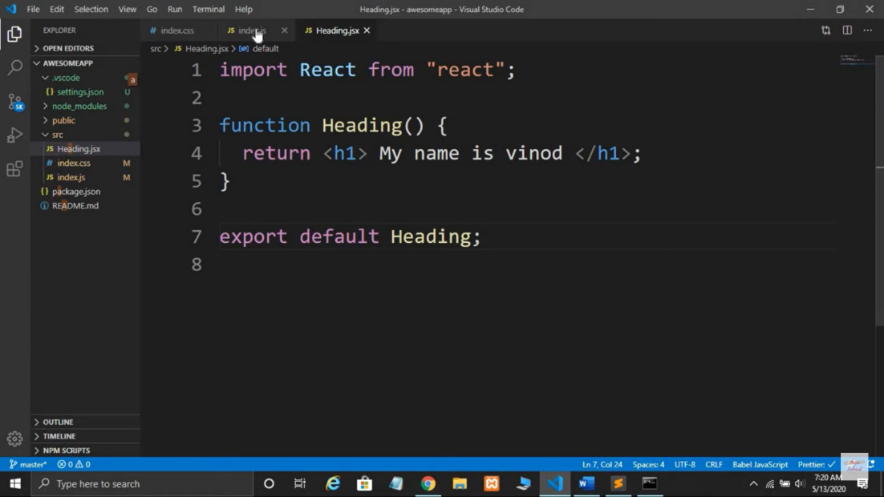

1. Now we will import this file in our js file as follows:

Similarly we can add as many components we need in this page. When we are exporting something from the page, the function name should be same as “export default ‘name’” but when we are importing it we can write any name for it and use it in our page.

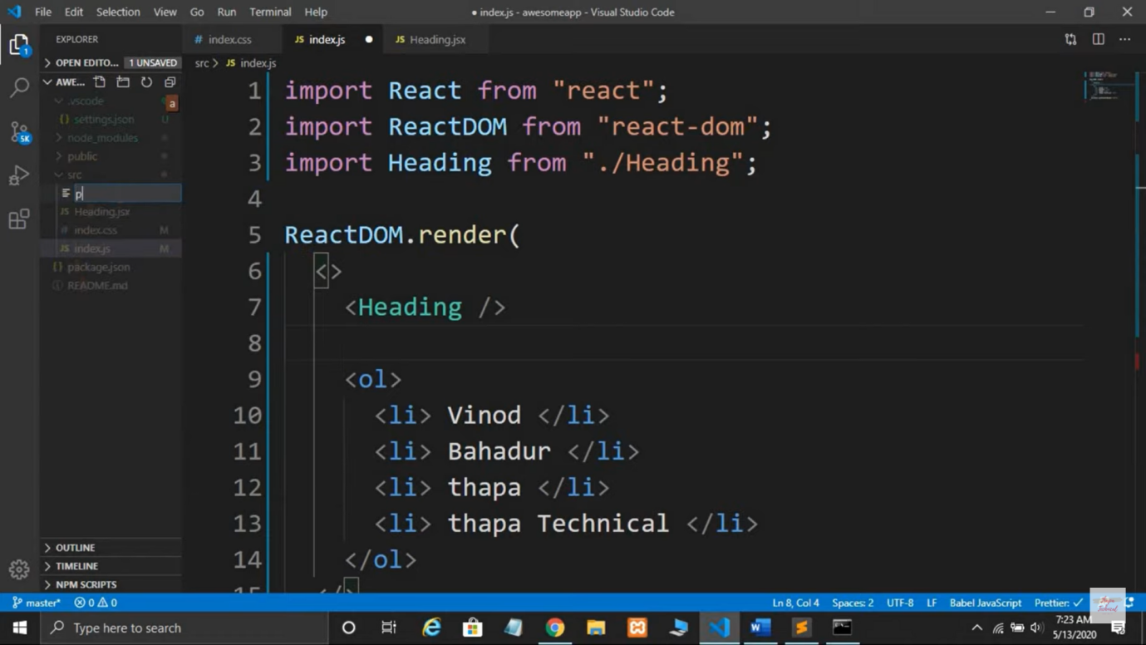

1. We can add all this components in a separate file and add a single jsx file here.
2. If we are writing multiple functions or variables in a jsx fle and we want to export all of them, so we can write like this:

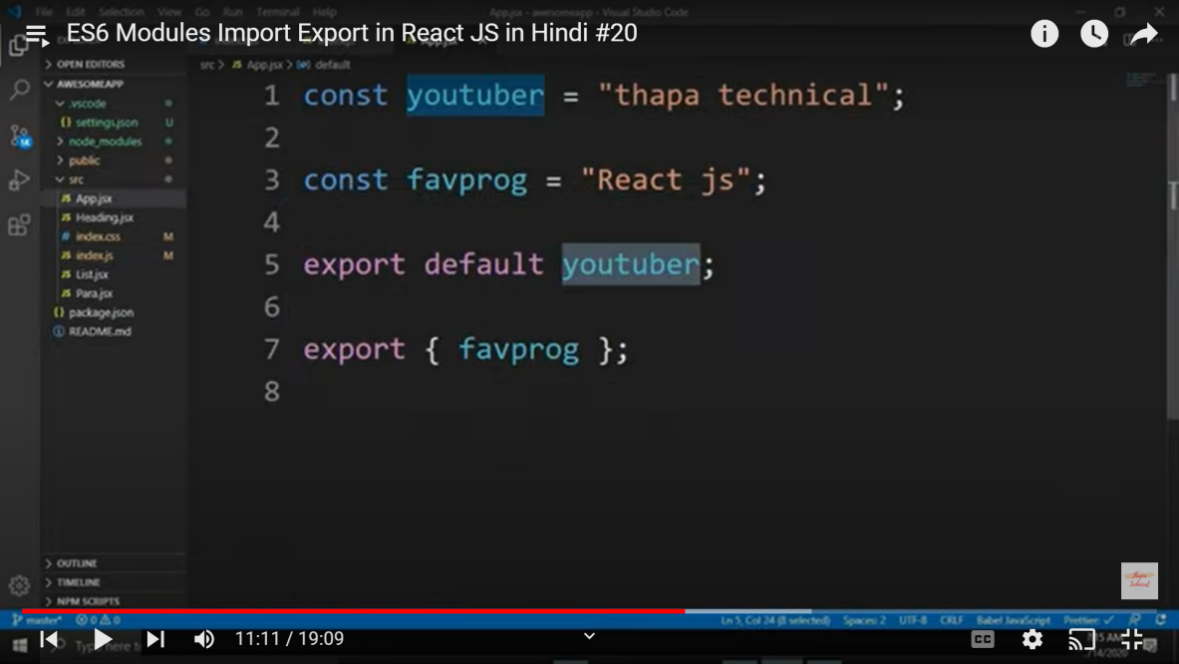

1. Now we will import it as follows and use it like this:

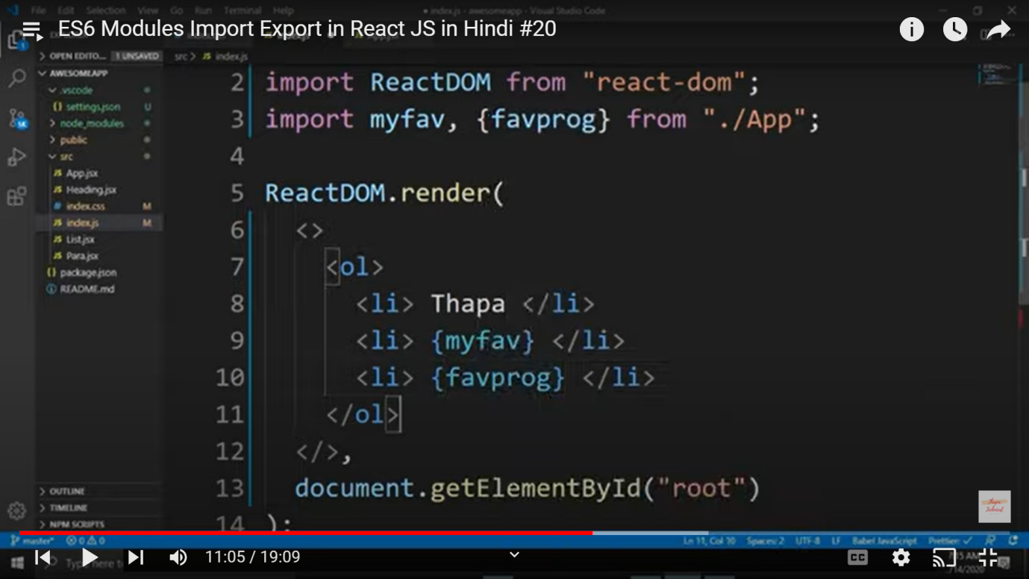

Here we cannot import by changing the variable name, we can write anything in place of myfav as we are sending it by default. But when we are sending anything in variable form we have to write it as it is. We use this variable by writing it inside curly braces.

1. We can add many functions but we can only write one default. Rest of the variables and functions are added adding commas (,). Even if it is function we don’t write function(), instead we write function only.  
   When we define this in next page then also we write variable function but when we define this somewhere in the code we have to give parenthesis bracket also like function().

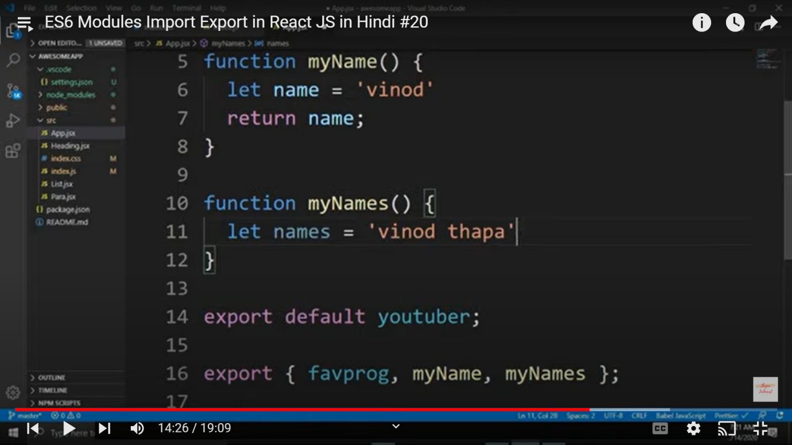

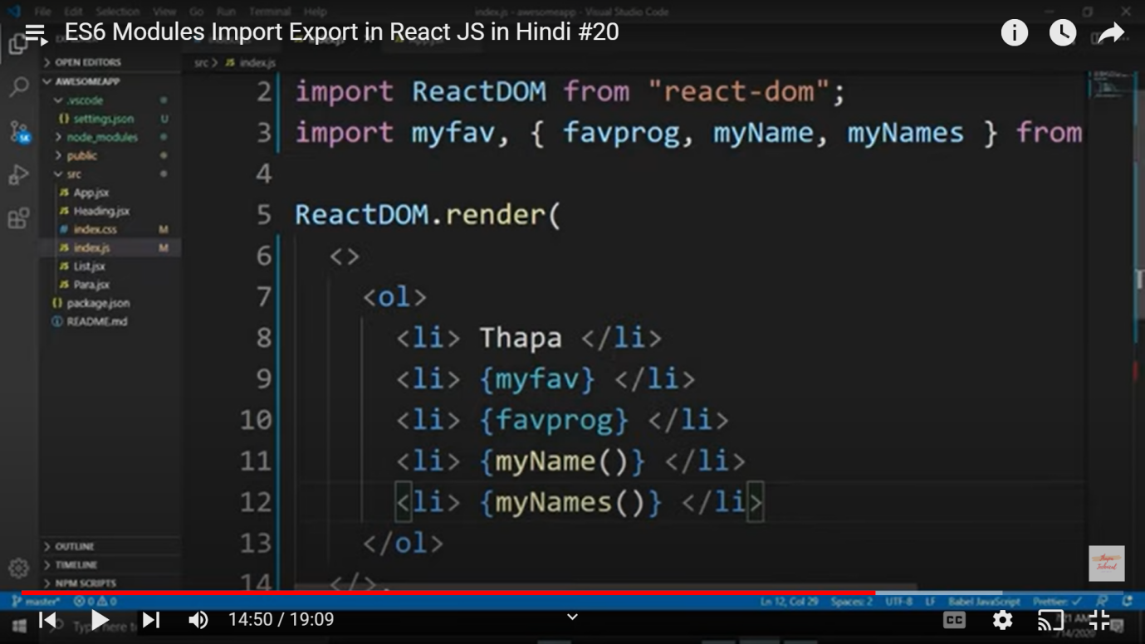

1. Instead of adding every variable explicitly we can write * there to add all variables and functions.

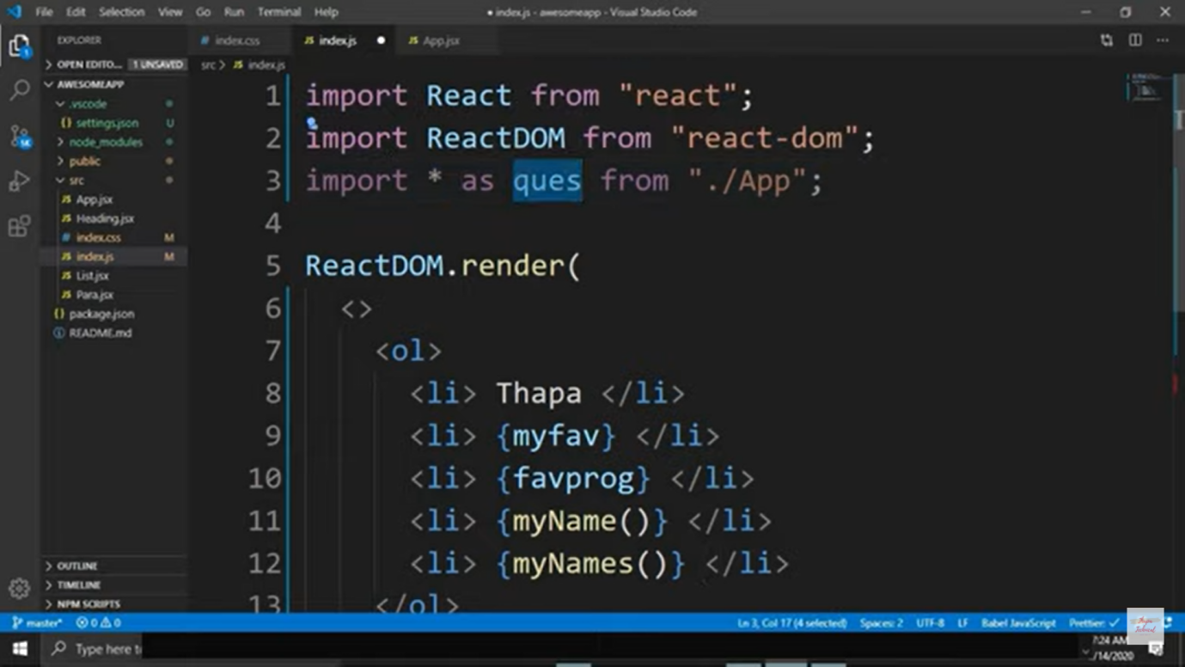

1. We can use this variables like this in our code. And for the default variable we variablename.defalt.

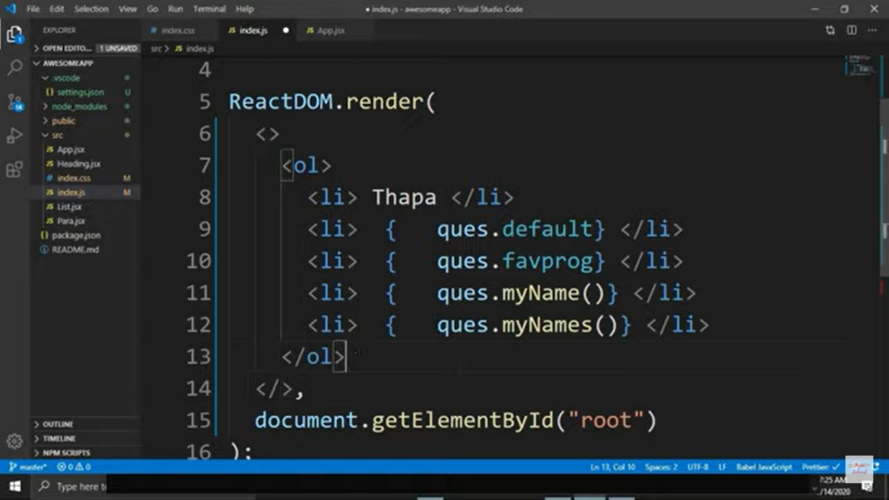

1. Props (or Custom attributes):

These are the attributes which we create ourself and give them values.

What we will do here is, we will create a Card.jsx file and write a function inside it with name Cards. We will write all the html and css code which will display 1 card which contains img, link and title. But we cannot hard code it as we want different data for different cards. So we will make a single card and manage attributes by ourself like this:

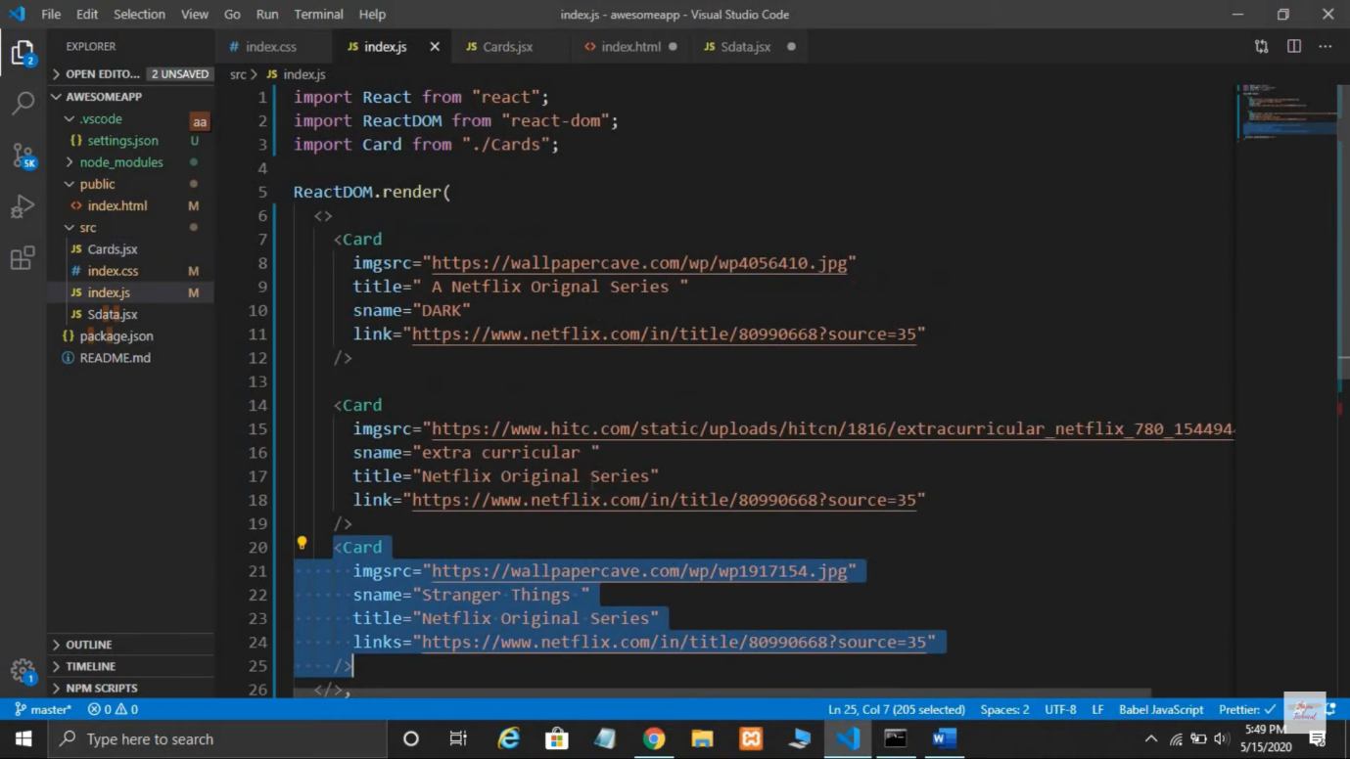

The attributes given here like imgsrc, sname, link are given by ourself which will go to card function and get imbedded in Card function variables.

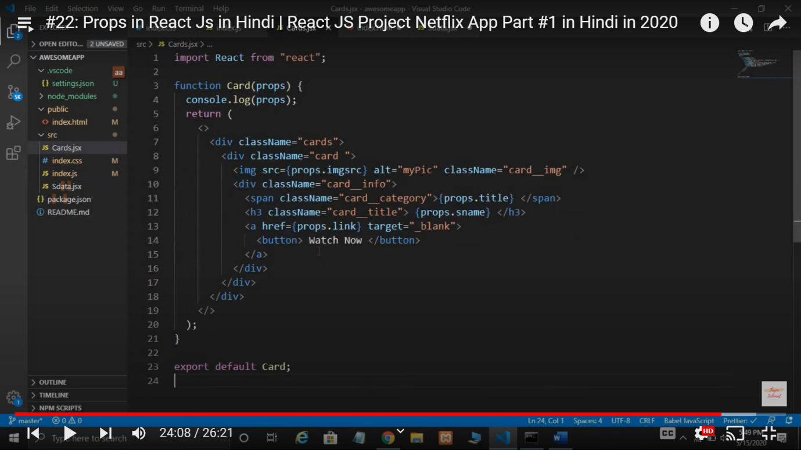

Here we have given in parameter – props, we can write any name in place of props. To use props, we write {props.imgsrc}, {props.sname} and {props.title}. In this way, we create different components and add them very easily.

Note: If I want to print all the props values then we can simply write console.log(props) and we will see that all the objects key value pair will be printed in console.

1. Now to make it more short and precised we will create another page name Sdata.jsx which has array which contains all data. Variable name is Sdata.

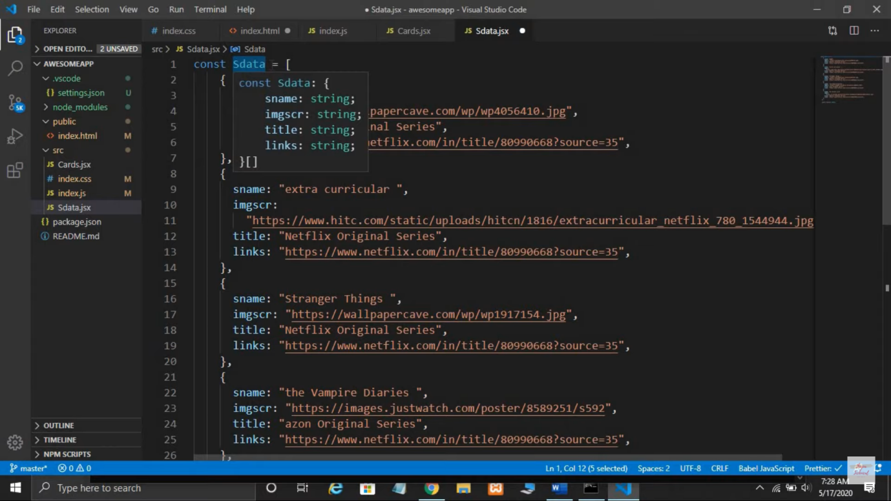

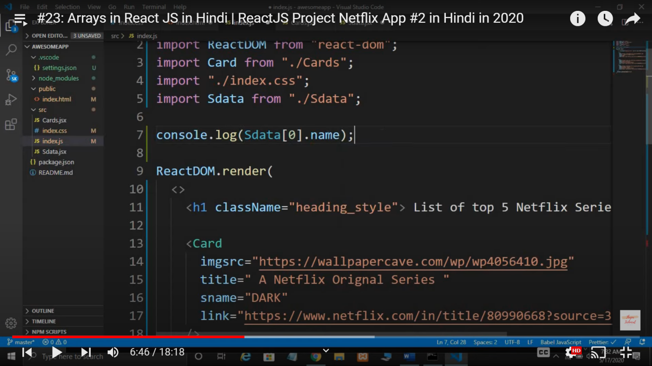

We will give values to imgsrc as follows

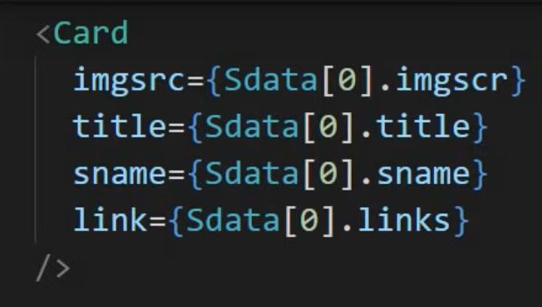

Now we will use a method of arrayName.map() so that all the array elements one by one.

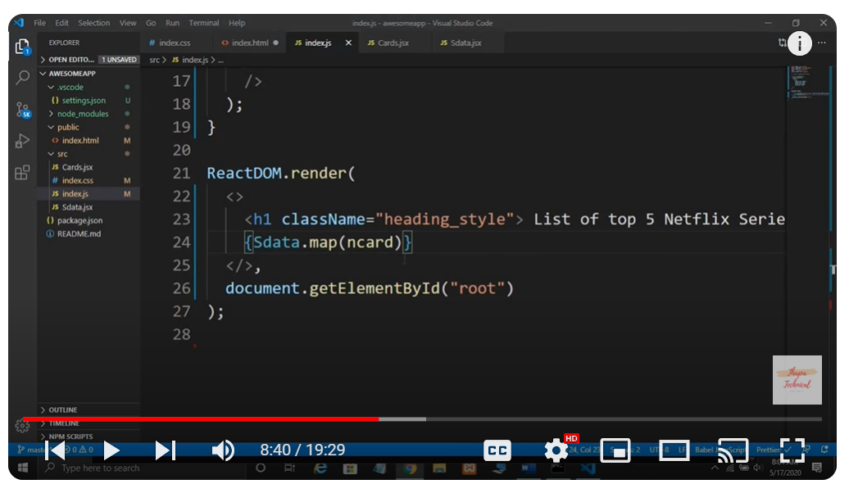

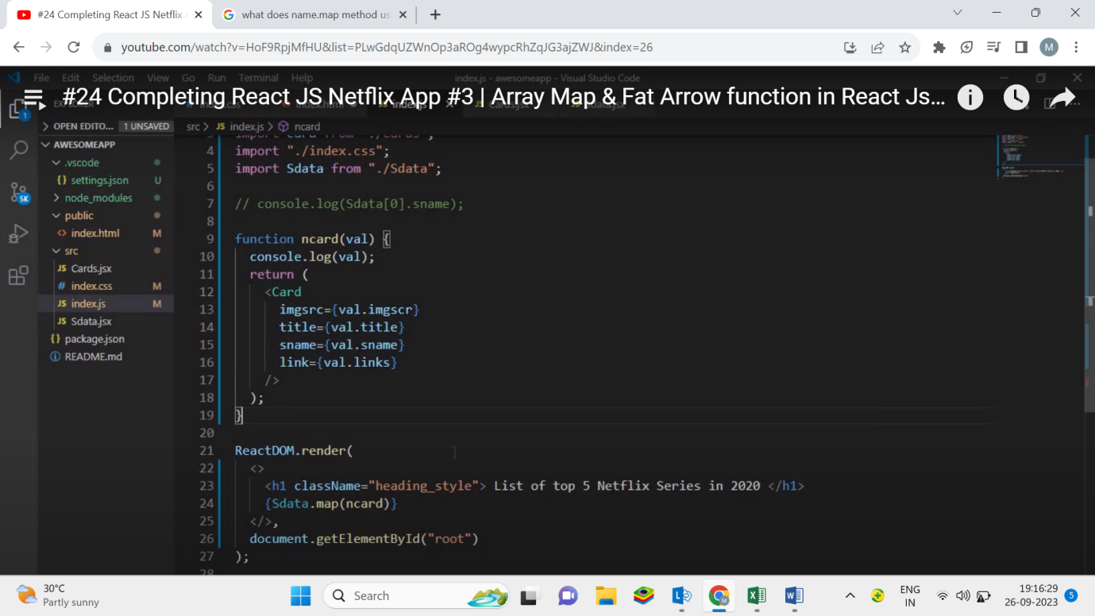

1. **We can also write it like this:**

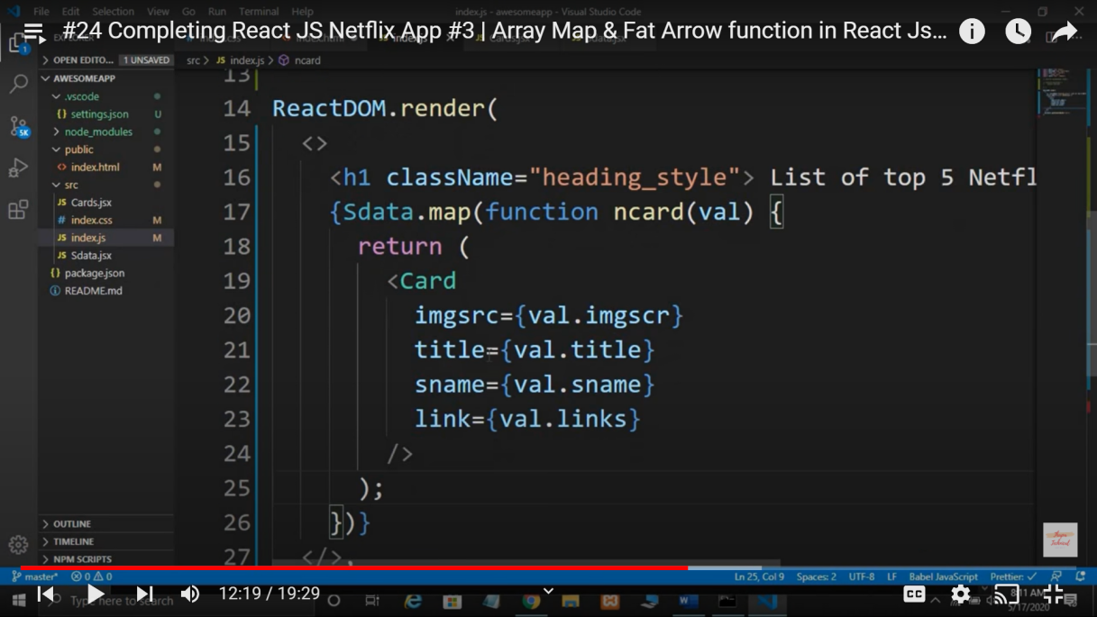

1. **This way we can perform different actions in each index value of an array.**

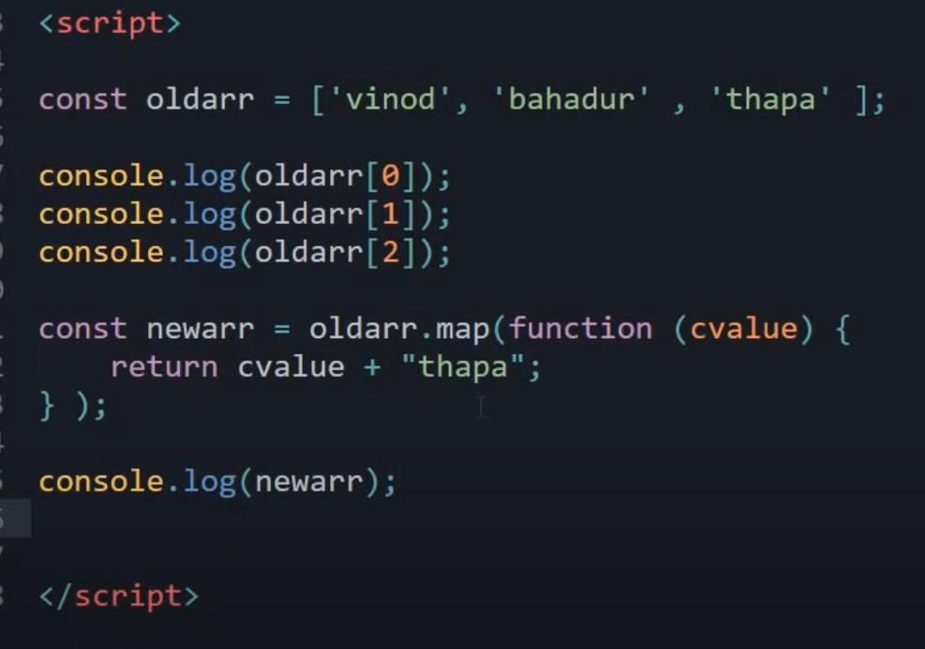

1. For all the database, we need a unique key which will help us to distinguish between all the entries. So it is compulsory to give a variable to each array object with any name. But when we will use it in code we will write “key” as it is.

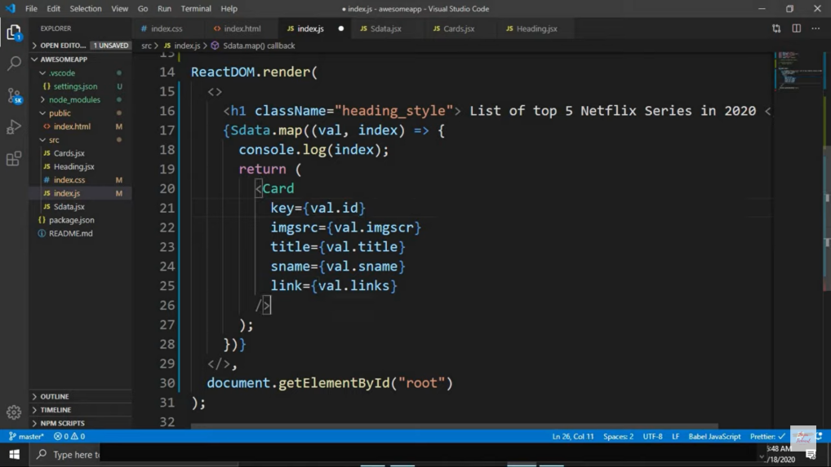

1. Use of ternary operator:

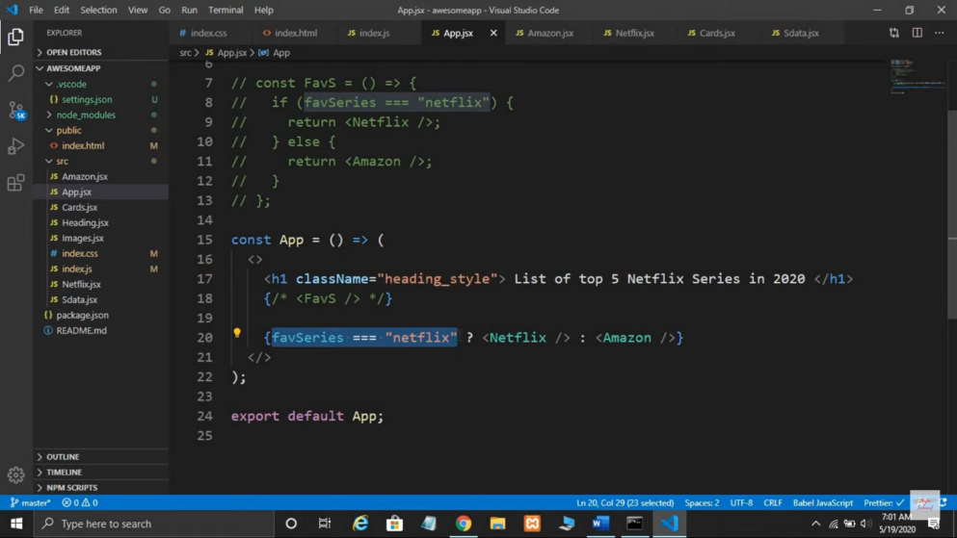

1. Example of object-destructuring is:

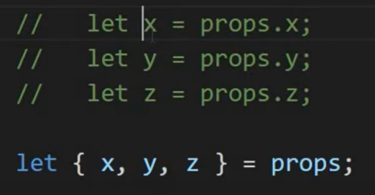

1. Button : OnClick functionality

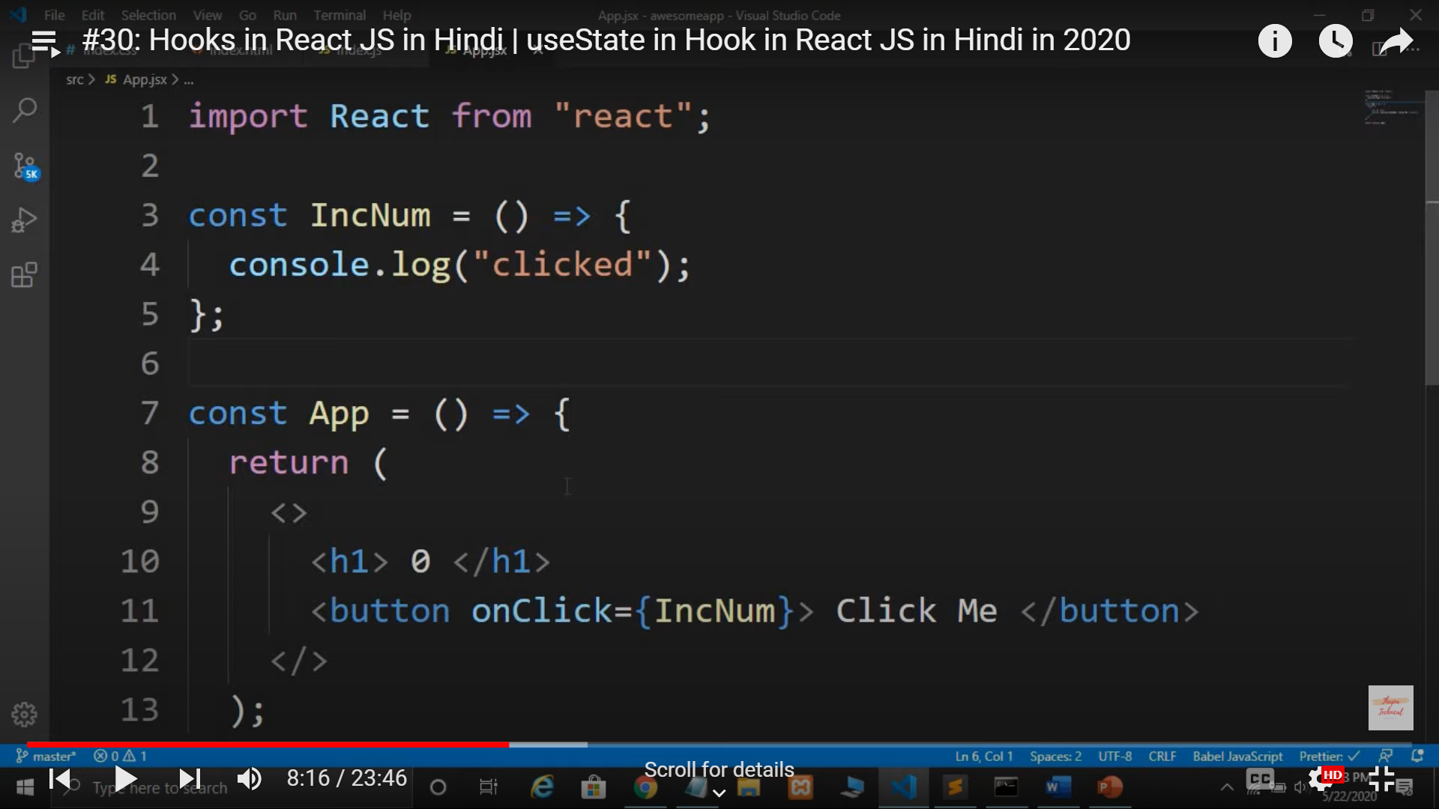

1. Array destructing one more example,

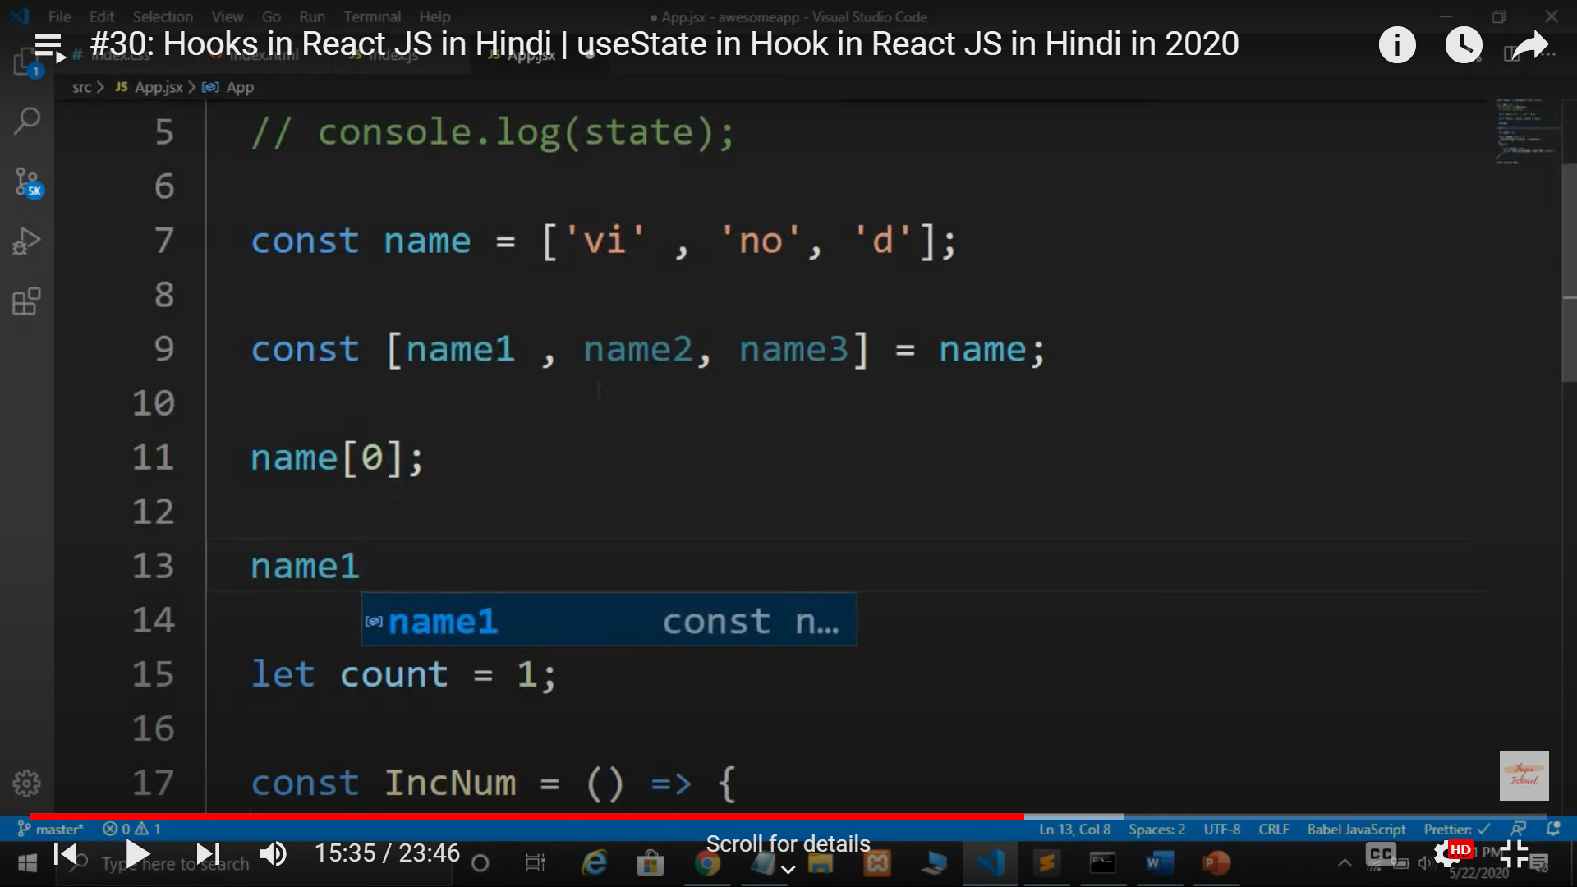

Whenever we destructure and array of string, the index value name becomes the direct variable for that string.

1. Hooks